**Gym Companion App Proposal**

## **Proposal Overview**

The Gym Companion app is a workout-tracking application designed to help users log their exercises, track progress, and access workout-related information. This app will feature a Login page, Home page, Workout log page, Strength progress, Exercise search page, Profile page. This app will also use the ExerciseDB API.

## **App Features**

### **Core Features**

1. **Login/Create Account** – Users can login/create an account.
2. **Workout Logging** – Users can manually log their exercises, sets, reps, and weight.
3. **Progress Tracking** – Visual progress tracking through graphs and stats.
4. **Exercise Library** – A list of exercises with descriptions, benefits, and instructions, fetched dynamically from an external API.
5. **Workout History** – Users can view their past workouts.
6. **User Profile** – Stores user preferences, goals, and basic information.

## **API Integration: ExerciseDB API**

The app will use the **ExerciseDB API** to fetch exercise details dynamically. This API provides:

* Exercise names, descriptions, and targeted muscle groups.
* Animated GIFs for visual guidance.
* Search functionality based on body part or equipment.

Example API call:

GET https://exercisedb.p.rapidapi.com/exercises/bodyPart/{bodyPart}

Response:

{

"id": "0007",

"name": "Pull-Up",

"target": "Lats",

"equipment": "Body weight",

"gifUrl": "https://example.com/pullup.gif"

}

This data will be displayed in the Exercise Library Screen, allowing users to browse and learn new exercises.

## **User Stories**

* As a user, I want to log my workouts so I can track my progress.
* As a user, I want to see my workout history so I can analyze my performance over time.
* As a user, I want access to an exercise library so I can learn about different workouts.

## **Screens & Wireframes**

1. **Login/Create Account Screen** – Login/Create account screen.
2. **Home Screen** – Quick access to workout logs, history, and progress tracking.
3. **Workout Log Screen** – Users enter exercise details like sets, reps, and weight.
4. **Progress Screen** – Displays graphs and statistics on workout progress.
5. **Exercise Library Screen** – Lists exercises with descriptions and tutorial links, fetched from the ExerciseDB API.
6. **Profile Screen** – Stores user preferences and basic fitness goals.

## **Wireframes**

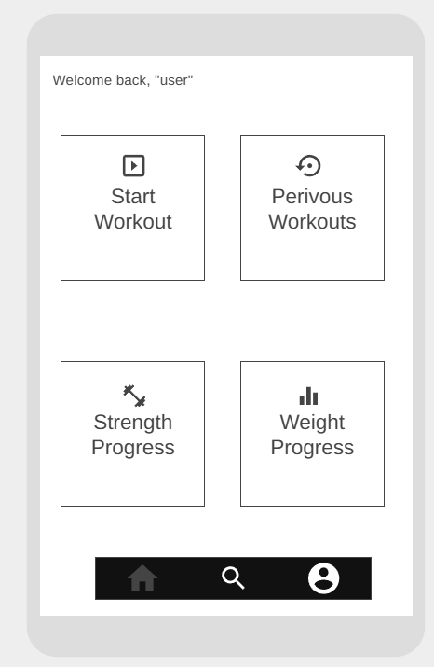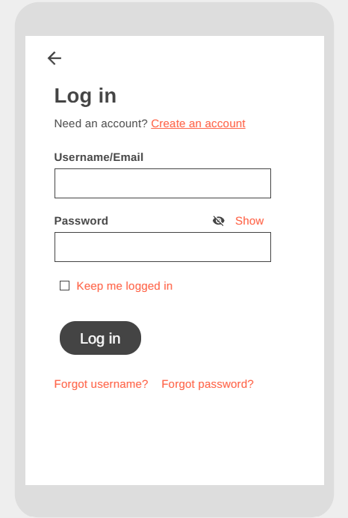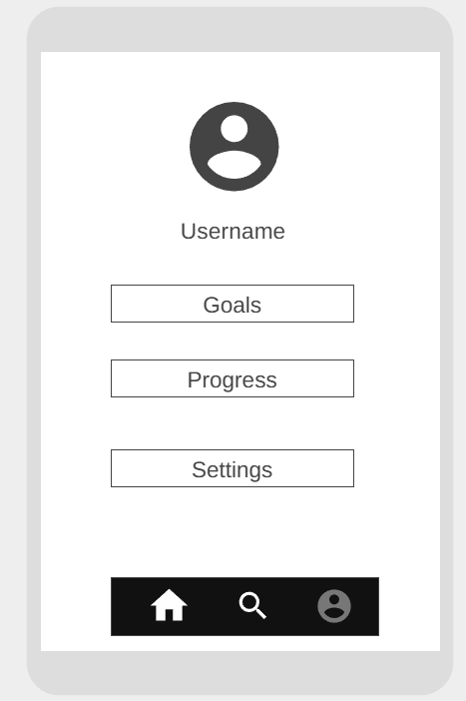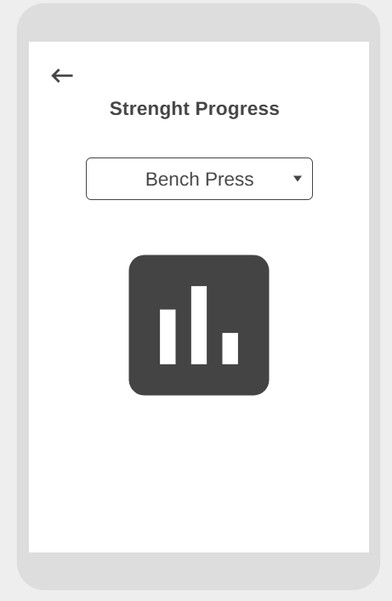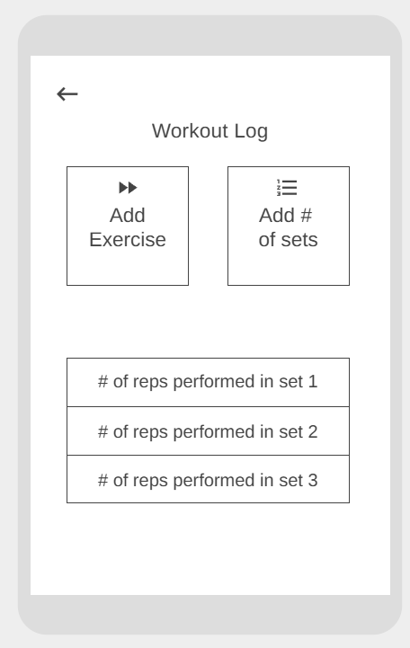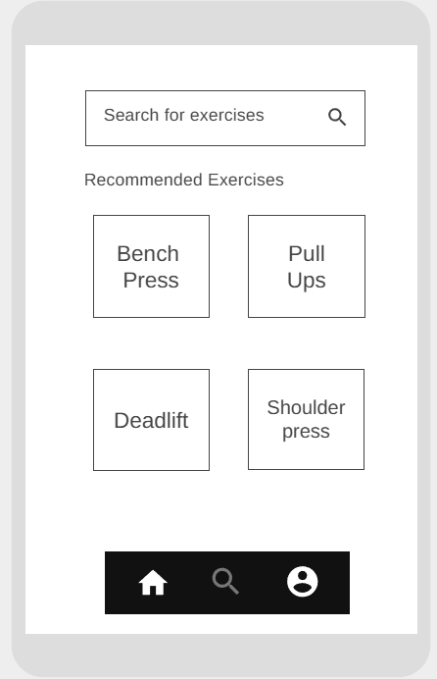

ht https://wireframe.cc/9bvo4vtps://wirefram

e.cc/9bvo4vhttps://wireframe.cc/9bvo4v